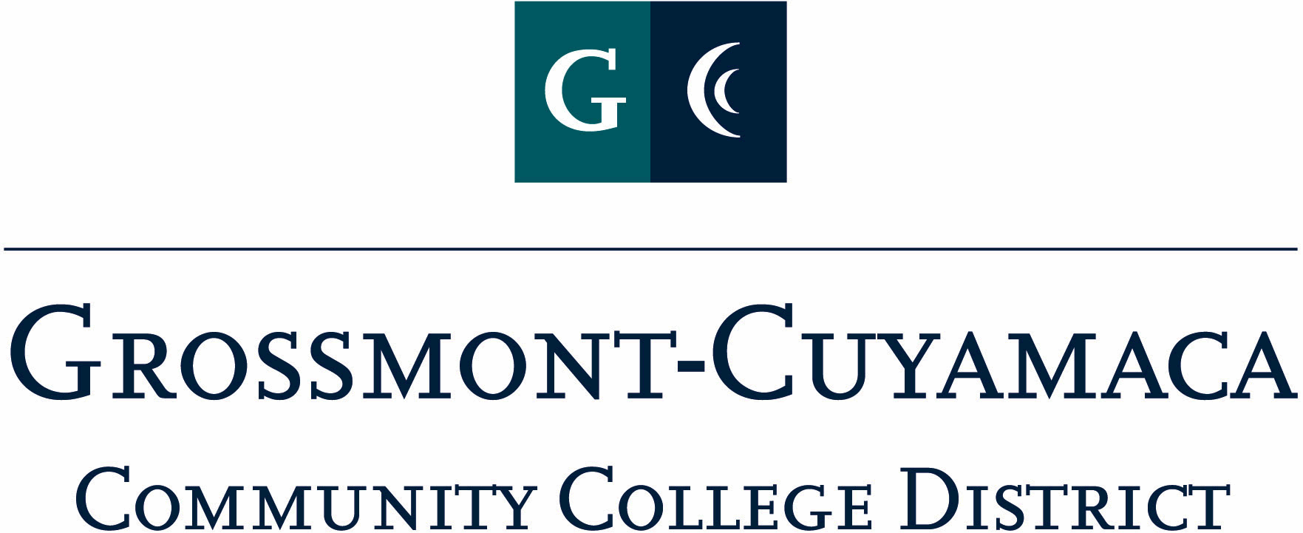
CLASSIFIED SENATE
EXECUTIVE BOARD MEETING
April 14, 2009– Meeting Minutes

Members Present:

1. Welcome and Call to Order
The meeting was called to order at 12:10 and quorum was not met.

2. Approval of Minutes from 12/1/2008
The Executive Board meeting minutes from 2/3/09 and the Annual Organizational Meeting Minutes from 3/5/09 will be e-mailed for approval.

3. Communication

VP Reports

District: Paul Tillery reported that there was nothing new with the Budget. The President inquired as to an update on the District Survey. Paula indicated that Bob Hertel’s office was handling.

Grossmont: Pat Murray reported out that the Response to Recommendations for Follow-up Accreditation Report has not been sent out district-wide for feedback YET. The Accreditation Steering Group would be garnering feedback and will meet once more on April 25th. Thereafter the response to all recommendations will be disseminated to all as well as posted to the website. Final documents will be given to the accreditation team according to the timeline sometime in August.

District Survey: Pat Murray encouraged everyone to take time to fill out the Survey.

Planning & Resource Committee (P & RC): Pat Murray indicated that Chris Hill, Grossmont College Academic Senate President, referenced a Planning Map and flow chart at a recent retreat when developing a sub-committee that would be approving campus activities. The subcommittee is called “Institutional Review Committee”. Trend statements were presented at the Campus Leadership Retreat to develop data-driven decision and vision activities for the next strategic planning cycle. The committee considers SLOs, college goals etc. when deciding on funding and will make recommendations to Planning and Resource Council. Pat will report what is presented at the next P &RC meeting.

Cuyamaca: Maggie Gonzales addressed the following matters:

Committee membership: It would be an advantage to have a list of those classified representatives on shared governance committees. This was visited by Rocky Rose, Shari Ball and Jan Recktenwald several years ago. The President suggested that this be put on the agenda for the Fall Retreat.

Classified Staff Appreciation Day: She is in the process of sending out thank you letters to the vendors who supplied the give away gifts for the raffle.

President’s Report: Debi Miller went over the following items:

C&Bs Voting Results: The Voting Results from Classified Staff Appreciation Day on the items that were presented to the membership were passed. Since a quorum was not met at this meeting, the E-Board will ratify through e-mail.

Nomination Memo okay? The nomination memo needs to be mailed out and the President needs the E-Board to approve the newest version. Since quorum was not met at this meeting, the E-Board will be e-mailed for approval.

CSAD Debrief Meeting? After Work? The group was solicited for possible days that would work for a debriefing meeting after work. The group asked the President to send out several dates. The President indicated that a majority would determine the date.

Treasurer Report: The Treasurer was not present. No report was given.

4. Continuing Business: Nothing was brought forward.

5. Fundraising Activities:

Padres Tickets: Rocky Rose, co-chair of the Padres fundraiser addressed the group. He reported that less than 50 tickets had been sold and has solicited both College Foundations to send to their database connections for possible interest. The group discussed the upcoming payment due for the May 16th game day. Paula Tillery indicated that there was less than $3,000 in the trust fund, and the payment due was approximately $3,500. Due to an anticipated short-fall the following tasks were established:
- Lynne Davidson, Nancy Asbury and Rocky Rose will go to those who owe money for the May 16th date and collect by next week
- Paula to discuss with Sue Rearic, the possible short-fall scenario
- Paula and Lynne to work on a new e-mail to go to the district, and send to President for final approval
- Rocky to keep the Executive Board updated on this matter

See’s Candy: Paula Tillery updated the group on this fundraiser:
$782.00 Candy Sold
$694.50 Cost to Classified Senate
$ 87.50 Profit on Sales
$106.50 Donations
$194.00 Total Profit

6. Governance: Nothing brought forward.

7. New Business:

CCSA Handbook for Review (1st Read): The President asked the group to review the handbook over the next month and send any suggested changes. A few edits surfaced at the meeting, and the President will make those corrections to the handbook. It will be brought forward for a second read at the next meeting.

Retreat Date: The President asked the group to consider two dates for the Fall Retreat – 8/7 and 9/25. Since quorum was not met, the E-Board will be e-mailed for their choice, and a majority will determine the date.

The meeting adjourned at 12:55.

